CS 207D- Computer Architecture  Second Semester 1434/1435H  Sheet #1 | 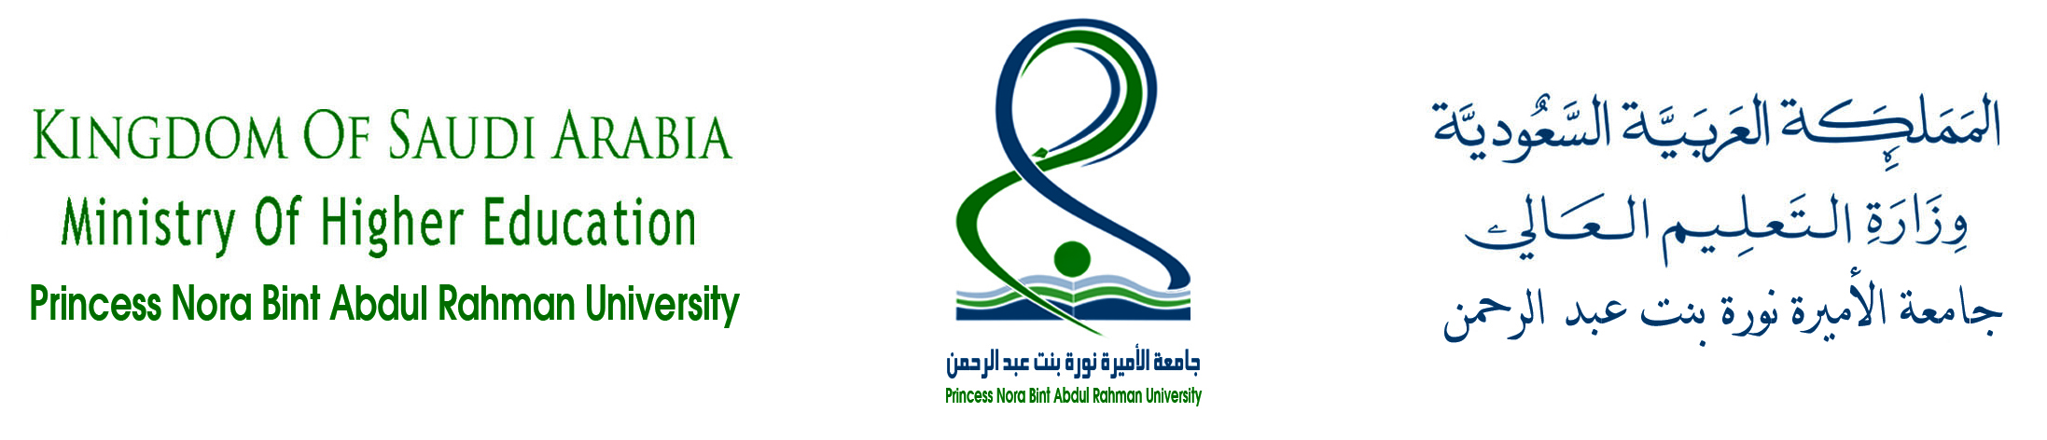  Princess Noura Bint Abdulrahman University  Faculty of Computer and Information Sciences  Department of the Computer Sciences  (
Q1
  - What is the distinction between computer structure and computer function?
  - What are the four main functions and components of a general purpose computer?
  - List and define the main structural components of a computer.
  - List and define the main structural components of a processor.
  - Explain Moore’s law.
  - Explain the key characteristics of a computer family.
  - Choose a computer or a computer family, state its features, its technology principal, then compare between it with the previous and next computer or computer family?
Q2 For the following IAS computer architecture, indicate the width in bits of each of the data paths.
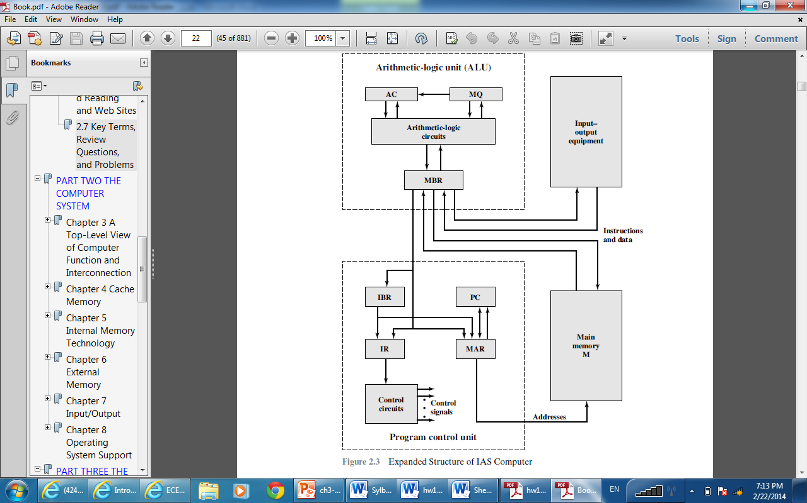

Q3 1- 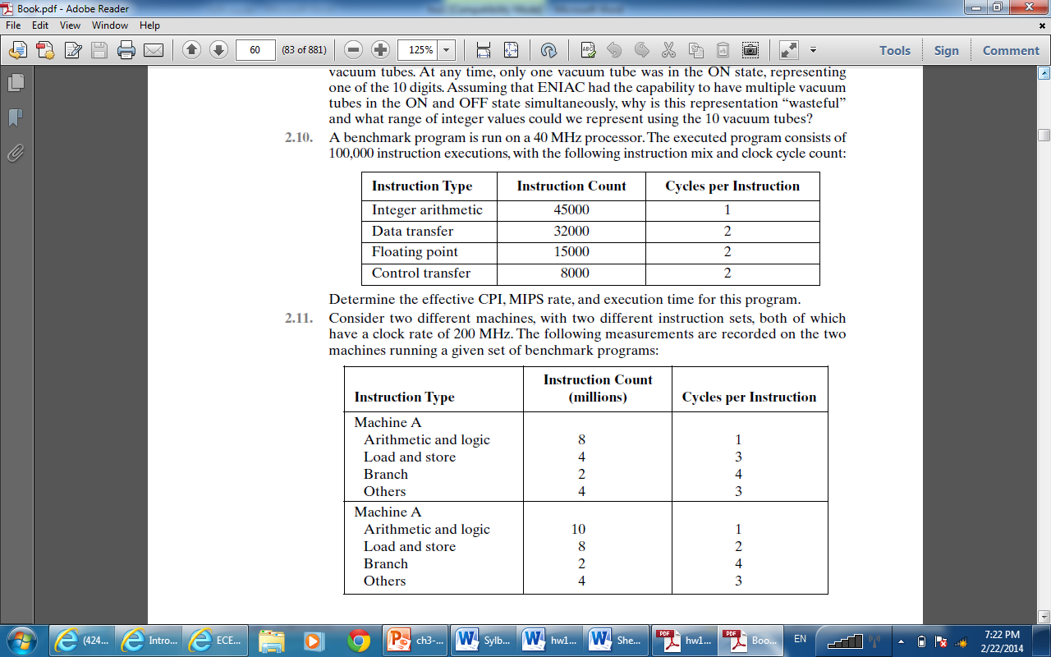

2-
3- 